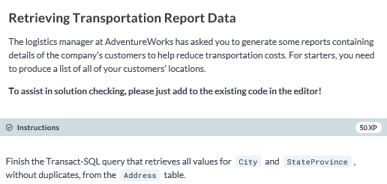

**SELECT DISTINCT City, StateProvince**

**FROM SalesLT.Address;**

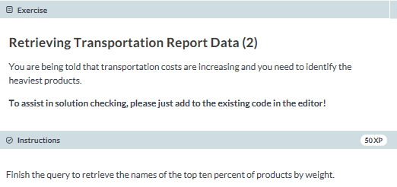

**-- select the top 10 percent from the Name column**

**SELECT TOP 10 percent Name**

**FROM SalesLT.Product**

**-- order by the weight in descending order**

**Order by Weight DESC;**

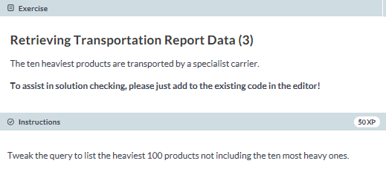

**SELECT Name**

**FROM SalesLT.Product**

**ORDER BY Weight DESC**

**OFFSET 10 ROWS FETCH NEXT 100 ROWS ONLY;**

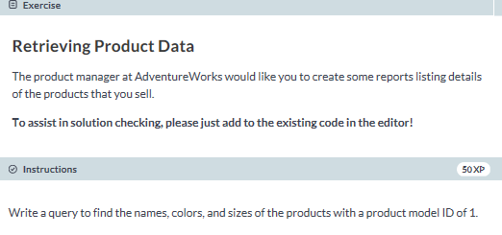

**SELECT Name, Color, Size**

**FROM SalesLT.Product**

**WHERE ProductModelID = 1;**

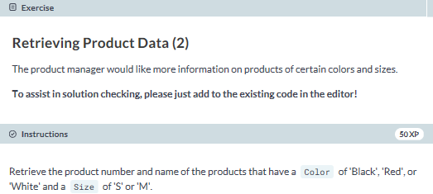

**SELECT ProductNumber, Name**

**FROM SalesLT.Product**

**WHERE Color IN ('Black', 'Red', 'White') AND Size IN ('S', 'M');**

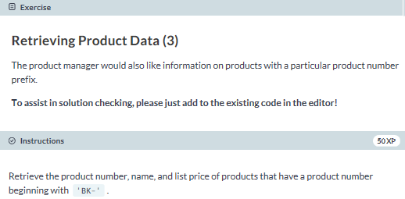

**SELECT ProductNumber, Name, ListPrice**

**FROM SalesLT.Product**

**WHERE ProductNumber LIKE 'BK%';**

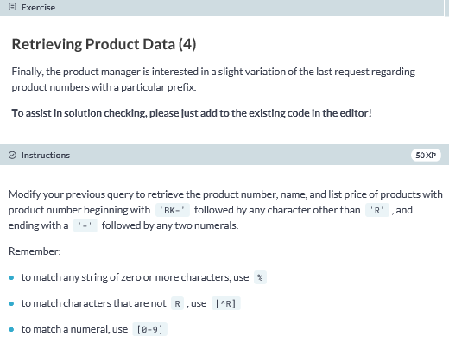

**SELECT ProductNumber, Name, ListPrice**

**FROM SalesLT.Product**

**WHERE ProductNumber LIKE 'BK-[^R]%-[0-9][0-9]';**